R Practical - Sample means tests
SOST10142/20142 Applied Statistics for Social Scientists
2023-03-06

1 Prep
Today we will do our first significance testing. Again, try to run all the commands below. Also, I will ask some questions about the analysis. Try to look at the results and answer the questions.
Before we start we need to install and load the packages.
#install.packages("tidyverse")
#install.packages("haven")
library(tidyverse)
library(haven)
library(psych) # desc stats using describe()
library(janitor) # tabulations using tabyl()
theme_set(theme_bw())
We’ll suppress scientific notation, 6.35e-14 and print 0.0000000000000635 instead.
options(scipen = 999)

2 One sample mean, t-test
For one-sample tests of means, you can do z-tests or t-tests depending on whether population variance is known. A z-test is appropriate when you know the population variance. However, it is highly unusual we have access to the information on the population variance, and this z-test is almost never used in real life. When population variance is unknown, we rely on the sample data to estimate sample variance to use in t-tests. We will use t-tests here and these are by far the most widely used. Unless you have a small sample, both tests yield similar results.
We will use European Social Survey (ESS) data. This is a survey carried out every 2 years in around 20 European countries. It asks respondents about a number of topics from politics to the environment.
We will focus on the full-time working hours. From earlier studies, we know Sweden is one of the countries where working hours are shorter than countries with other welfare regimes. Our hypothesis is whether Sweden’s weekly working hours is significantly different from the rest of the EU countries. The dataset has a variable called wkhtotp that indicates total hours normally worked per week in main job overtime included. The null hypothesis is that the mean will be 40 hours. The alternative hypothesis is that the mean will not be 40 hours. Using a two-tailed hypothesis, you can claim :
H₀ : 𝜇 = 40
Ha : 𝜇 ≠ 40
The original data is provided in a Stata (a different statistical package) format. I have cleaned and save the data in R. We can use read_rds to read in the data. To be able to access and further explore the data, we store it in an object called “data”.
data <- read_rds("ESS7e02_1_v2.rds")
We can have a glimpse of the data:
head(data)
#View(data)
Let’s look at the distribution of wkhtotp. It represents the total hours normally worked per week in main job overtime included.
library(janitor)
data %>% tabyl(wkhtotp) %>% adorn_totals()
Let’s visualise how the working hours vary by country. We produce a boxplot. For y-axis, we limit the scale running from 30 hours to maximum 80 hours. We have some outliers but we ignore them for this exercise.
data %>% ggplot(aes(x = country, y = wkhtotp)) +
geom_boxplot() +
scale_y_continuous(limits=c(30, 80))
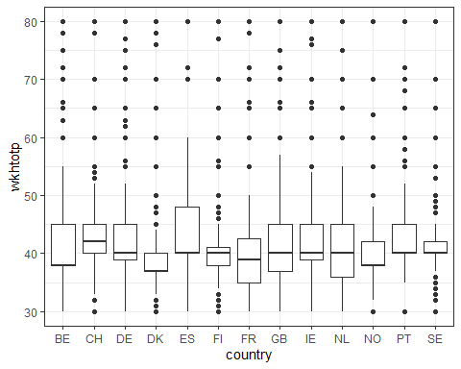
Let’s also produce a descriptive table. What is the mean?
describe(data$wkhtotp, fast = T)
We then keep Sweden data separately, and obtain the mean.
sweden <- data %>%
filter(country == "SE")
describe(sweden$wkhtotp, fast = T)
We can see Sweden’s average weekly working hours is marginally less than the EU average, we are interested whether Sweden’s average weekly working hours is significantly different from 40 hours. We perform a test. To perform a one-sample t-test, all we need to do is to supply a dataset name, add $ before providing the variable name, along with the value of the mean μ under the null hypothesis.
t.test(sweden$wkhtotp, mu = 40)
The output reports t-statistic, df, p-value, and 95% CI. The sample mean is reported on the last line.

2.1 Questions
Pause here and try to answer the questions. > Explain df and sample size. > Provide calculation of t-statistic. > What would you conclude?
What is the cut-off point we should use for a two-tailed test at the 5% level? 0.05 p value. Degree f freedom = sample – 1 2.5th perecentile 97.5th
How is the calculated t-statistic compared to the cut-off?
Does 95% confidence interval include mu? What does it mean? Shows we can be 95% confident that the population mean lies within the sample statistic range

2.2 Two approaches: Critical value and p-value
We can use critical value to test the hypothesis, by examining the calculated score against the cut-off value calculated in the previous question. Here, the test statistic is greater than the cut-off point (5.329 > 1.96), so we can reject the null hypothesis. How do we obtain 1.96, the critical value? For a 95% confidence interval, α = 0.05 (1-0.95). Given a two-tailed test, we cover both tails of the distribution by finding the 2.5th and 97.5th percentiles of the Student t- distribution with a corresponding degrees of freedom.
# Population SD is unknown, critical t for 2.5th percentiles
qt(0.025 , df = 653)
# Population SD is unknown, critical t for 97.5th percentiles
qt(0.975 , df = 653)
# Population SD is unknown, critical t for both 2.5th and 97.5th percentiles
qt(c(0.025, 0.975), df = 653)
To obtain p-value for a two-tailed test, we use pt() and specify t-statistic in the brackets, along with degree of freedom, which is sample size, n - 1. As pt(t-stat) will yield the cumulative probability from the left area, we need to perform 1 - pt(t-stat) then multiply by 2 to indicate it is a two-tailed test.
# 2-tailed
pt(5.326999, df = 653)
2 * (1 - pt(5.326999, df = 653))

2.3 Your task 1
gb <- data %>%
filter(country == "GB")
Carry out a one sample mean t-test using GB data.
Establish a null and alternative hypothesis.
Perform a two-tailed t-test.
Interpret the results : - Explain df and sample size.
- Provide the calculation of t-statistic.
- What would you conclude?
- Does 95% confidence interval include mu(𝜇)? What does it mean?
Alternative hypothesis GB has a statistically different number of years of education in comparison to the rest of the EU . resulted in it being statistically significant in difference sliglhty above average. P value is 0.0001

3 Two sample means, t-test
Let’s imagine we are interested in comparing the means of the two groups. For example, is there a difference between females and males in their trust of the parliament?
We already cleaned the trust in parliament variable. Lets have a look at the gender variable:
data %>% tabyl(gender) %>% adorn_totals()
describe(data$trstprl)
data %>% tabyl(trstprl) %>% adorn_totals()
Next, lets produce a group summary of the mean of trust in parliament by gender to see the group difference. We could use describeBy().
describeBy(data$trstprl, data$gender, fast = T)
We can see standard deviation of both groups look similar at 2.56 and 2.4. As such, we could carry out a t-test with the assumption of equal variance. The equality of variance assumption usually holds unless one group’s standard deviation is twice as large. As R’s default is unequal variance, there is no need to meet the requirement of equal variance.
The table seems rather busy. Let’s try another approach. We use group_by(gender) to define a grouping variable first, then by each gender, we obtain mean value of trstprl, as well as the count. As missing observations will cause error, we remove them by adding drop_na(trstprl).
data %>%
drop_na(trstprl) %>%
group_by(gender) %>%
summarise(mn_trustprl = mean(trstprl),
count_trustprl = n()
)
We can also do a visual representation using a box-plot. Recall we need to specify the grouping categorical variable at the x-axis.
ggplot(data, aes(x = gender, y = trstprl)) +
geom_boxplot(colour = "black", fill = "lightblue")
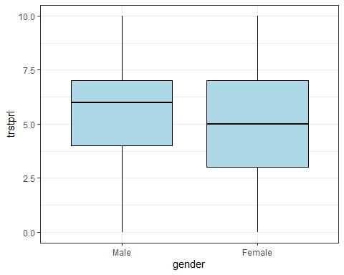
We can have another look at the two distributions in smooth density plots. The smoothing bandwidth is controlled by geom_density(bw = 1).
ggplot(data, aes(x = trstprl, fill = gender)) +
geom_density(bw = 1, alpha = 0.3)
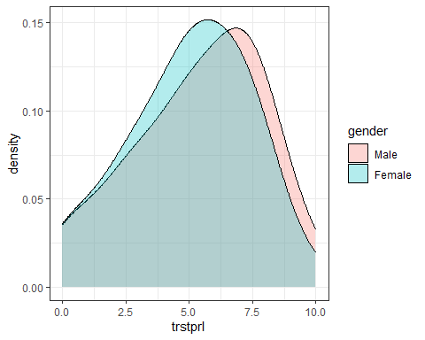

3.1 Questions
Which group has higher levels of trust based on our data? Males on average have more trust in government
Establish a null and alternative hypothesis. There is a statistically significant difference between mean trust in government between males and females

Next, lets carry out a t test and see if the differences are significant. Please note that Welch Two Sample t-test does not assume equal variance. For two samples t-test, there are two way of writing commands. They both yield same results.
t.test(trstprl ~ gender, data = data) # 1
# t.test(data$trstprl ~ data$gender) # 2
Answer these questions based in the results.
What is the t value? 5.9919
What is the p-value? 0.000000002193
what do these tell you about the the null hypothesis? What does that mean about the group differences? Tells use we can reject the null hypothesis and there is a true difference in the means between the groups
What is the confidence interval? Does it include 0? How do you interpret it? 95% confidence interval shows how much variance there may be within a 95% range
You can also add the option alternative ="greater" or alternative ="less" to see if the group 1’s mean is larger than the other.
t.test(trstprl ~ gender, data = data, alternative ="greater")
Has the conclusion changed?
The conclusion has not changed however the p values have changed and so have the confidence intervals

3.2 Your task 2
Follow the same procedure and answer the same questions regarding gender differences and trust in the UN using the trstun variable.
ggplot(data, aes(x = gender, y = trstun)) +
geom_boxplot(colour = "black", fill = "lightblue")
ggplot(data, aes(x = trstun, fill = gender)) +
geom_density(bw = 1, alpha = 0.3)
Obtain the mean value of trstun grouped by gender. There is a small difference.
describeBy(data$trstun, data$gender, fast = T)
data %>%
drop_na(trstun) %>%
group_by(gender) %>%
summarise(mn_trustun = mean(trstun),
count_trustun = n()
)
t.test(trstun ~ gender, data = data)
t value = 1.3409
p value = 0.18
null hypothesis rejected there is a true difference between males and female sin trust in the UN
End

